Stem Cells May Repair "Irreversible" Heart Damage

In December 2011, I reported on one of the first attempts to inject stem cells into damaged hearts. In that study, published in The Lancet, scientists grew stem cells from patients’ own hearts after the patients had suffered serious heart attacks. These were patients who had serious, irreversible heart damage. As the study leader, Dr. Roberto Bolli, said at the time,
“Once you reach this stage of heart disease, you don’t get better. You can go down slowly, or go down quickly, but you’re going to go down.”
Amazingly, in that study, the patients got better. 14 of the 16 patients had improved heart function after 4 months, and the results were even better after one year. The stems cells grew into new, functioning heart cells.

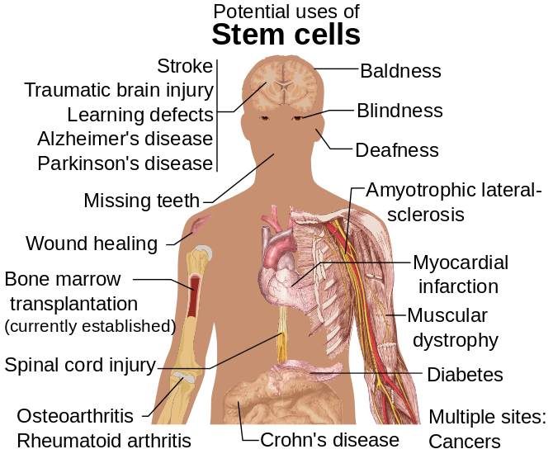Diseases and conditions where stem cell treatment is promising or emerging. Now we can add heart disease to the list. (See Wikipedia:Stem cell#Treatments.) Model: Mikael Häggström. (Image credit: Wikipedia)
That was just one study. Now there have been more, and the results continue to be very encouraging. Just last week, the Cochrane Collaboration published a review of 23 trials, all of them attempting stem cell therapy for heart disease. These trials looked at the use of bone marrow stem cells in patients whose hearts were failing. Unlike the 2011 study, which looked at heart attack patients, these studies looked at patients with advanced heart disease who had not suffered a heart attack. The results: overall, stem cell treatments reduced the risk of death and improved heart function, though the benefits were not as dramatic as in the patients with heart attacks.
What is most exciting in the newest studies is the long-term reduction in the risk of death. Six of the studies reported long-term results (more than one year) on mortality. In these studies, 8 patients died out of 241 who received stem cell therapy (3.3%). In contrast, 30 patients died out of 162 (18.5%) who did not receive stem cells. The numbers are small, but this is a huge benefit: patients were about 5 times less likely to die. The Cochrane review concluded that
“The risk of mortality over long-term follow-up was significantly lower for those who received BMSC [bone marrow stem cell] therapy.”
An important caveat is that this is still “low quality” evidence, meaning that we need to see more data, on many more patients, before we can have confidence in the results. But it is still very encouraging, especially when no other treatment offers anything remotely this promising for advanced heart disease.
The evidence continues to build that stem cells can repair heart tissue damaged by heart attacks. Just a couple of months ago, Britain launched the largest study yet of stem cell treatments for heart attacks, involving 3,000 patients in Europe. This new review shows that they can help repair some of the damage from other types of heart disease as well.
Heart disease is the leading cause of death in the United States, and we should be pursuing every plausible treatment, though very few exist. Stem cells offer the hope that, for the first time ever, we might be able to reverse heart damage that was previously thought to be irreversible. Stem cell treatments are a true breakthrough, and rather than cutting medical research, as we have been doing for the past five years, we should be pouring resources into this remarkable new medical technology and the therapies that it makes possible.

